Devika.B
Roll no: 22

1. Display following messages on your terminal (including quotes and newline).

“God bless us!
We are starting with basic linux command”

2. Read your name from the keyboard and display it.

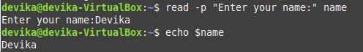

3. Create the directory structure dir1/dir4 and dir1/dir2/dir3 with a single command and then
change directory to dir3

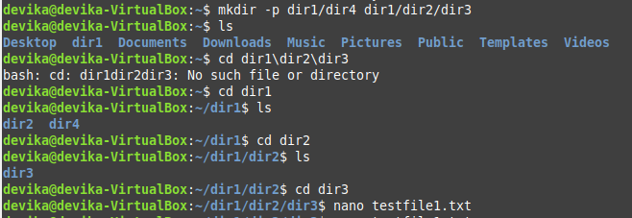

4. Create some files using nano and touch

5. Display the current directory

6. Listing files and folders
- List the contents of dir1 and all its descendants

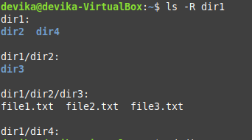

- List the contents of dir3 in
- Alphabetic order

- Sorted on time of modification, newest first

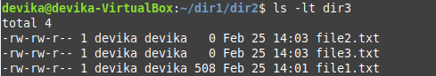

- Sorted on size

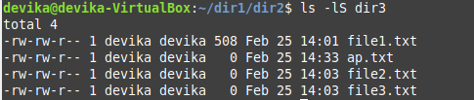

- Reverse order

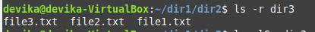

- Long listing of files sorted on size with smallest first

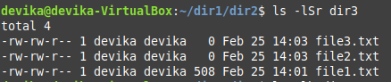

- Displayed in human readable form

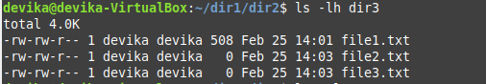

7. Execute ls and store the output to a file lsoutput

8. Display the file
(i) starting with the first 10 lines and

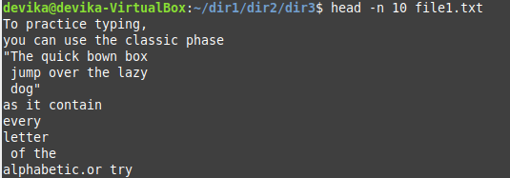

(ii) starting with the 10th line with provision for
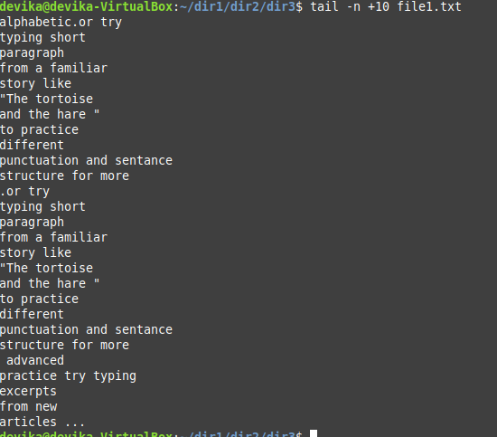

a) Scrolling Up

less lsoutput

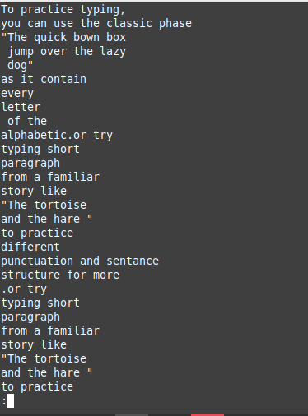

b) Scrolling Up and Down

less lsoutput

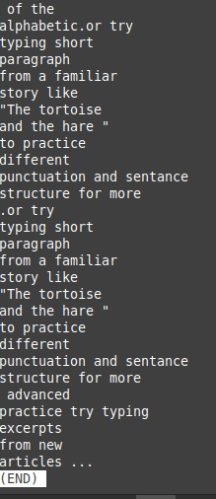

9. Get the manual page of ’ls’ command. Search for the word ”alphabetic”. Find the next
occurrence and then find the previous occurrence.

man ls
next occurrence:
Press n.
previous occurrence:
Press Shift + n.
